MENG 4010 - INDUSTRIAL NETWORKING

CONFIGURING IP ADDRESS OF
CONTROLLOGIX 1756-L81E PLC & SIEMENS S7-1200 G2

Student Name & Number: Michael McCorkell (N01500049)
Lab Date: September 10th, 2026

Objective
This lab guides students through methods for assigning or changing the IP address of a ControlLogix PLC (model 1756-L81E) and a Siemens PLC (model S7-1200 G2). Students will gain practical experience using communication tools and software environments commonly used in industrial settings.
Upon completing this lab, students will:
- Understand how to configure PLC network settings using USB serial, BOOTP/DHCP, and Ethernet methods.
- Demonstrate the ability to validate IP changes using system tools.
- Identify the advantages and limitations of each method.
The IP Address of a ControlLogix PLC 1756-L81E can be changed using the following methods:
- Serial Communication
- BOOTP/DHCP Server
- RSLinx Software
- Studio 5000 Software
The IP Address of a SIEMENS S7-1200 G2 can be changed using the following method:
- TIA Portal Software

Demonstration Requirements
Students will assign an IP address to the AB ControlLogix PLC and SIEMENS S7-1200 G2 using methods listed above. Take a screen capture of PING command for each part of the assignment and clearly document the IP Address of the PLC before and after the change.

Lab Report Requirements
The lab report must contain:
- Instructor’s Confirmation
The course instructor’s signature is required to verify the completion of the lab. Please ensure this is included with your report’s submission.
- Assignment Summary
Provide a clear summary of the assignment, detailing the objectives, a description of the work completed, and your conclusions.
- Program Documentation
Attach screenshots that you have collected over the duration of the lab, make sure to clearly specify IP addresses before and after the change.
- The lab report will be assessed based on the lab marking rubric provided on Blackboard. Please review the rubric to ensure all criteria are met.

Application Photos
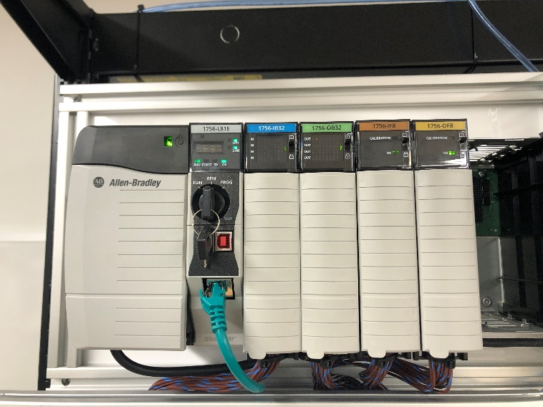 | 